**System Test Procedure Specification**

* 1. **Test Case Specification Identifier**

TPS-02-06 2014-05-22

* 1. **Purpose**

This procedure describes the steps necessary to perform the test specified in the test design specification for PlasmaGraph feature “Create Graph” TCS-02-06 **[see *TDS-02-XX section 2.4*]**.

* 1. **Special requirements**

No special requirements are needed to execute this test.

* 1. **Procedure steps**

1. ***Execute PlasmaGraph***

In order to launch the application the tester must click on the PlasmaGraph icon.

1. ***Import the data file provided into PlasmaGrap***

To import the data file provided the tester have to click on the data option located in the top menu of the tool bar. After doing this a menu with two more options will appear. Click on “Import Data”.

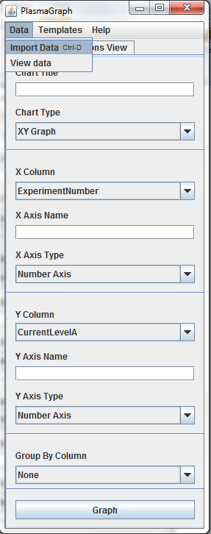

1. ***Select data set for the X axis***

To choose which data is going to be represented in the X axis the tester must click on the X column option located in the tool bar. The column to be used for the X axis in this test case is Temperature2eV.

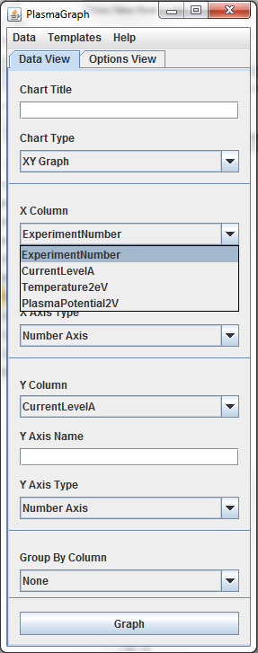

1. ***Select data set for the Y axis***

To choose which data is going to be represented in the X axis the tester must click on the X column option located in the tool bar. The column to be used for the X axis in this test case is PlasmaPotential2V.

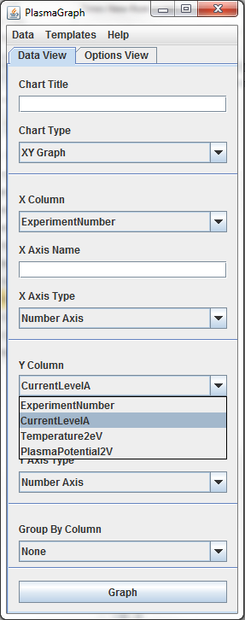

1. ***Create Graph***

To choose which data is going to be used for grouping the tester must click on the Group By column option located in the tool bar. The column to be used in this test case is ExperimentNumber.

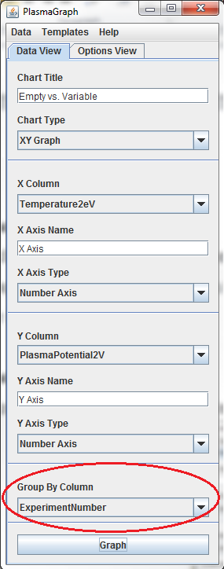

1. ***Create Graph***

To create the graph click on the “Graph” button located in the tool bar.

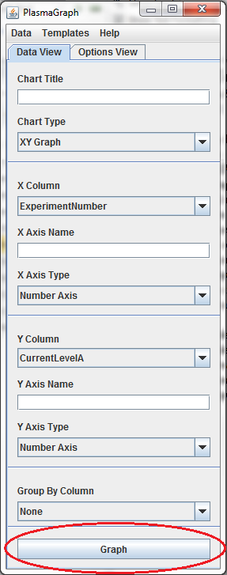

1. ***Compare outputs***

The tester must examine the graph produced by the program and determine if it complies with the expected output specified in the test case specification for this case ***[see document TCS-02-06 section 4]***.

1. ***Repeat for other OS***

Repeat steps 4.1 through 4.6 under the following operative systems:

1. Windows 7
2. Ubuntu Linux 14
3. Mac OS X 10